Rate sheet upload & Rate Card Creation

Rate Sheet Flow
When a forwarder uploads their contract rate sheet to the platform via the My Rates Rate Upload feature, a notification is sent to the BP team. The uploaded rate files become visible in the Admin Portal Files Module.
The BP team uses the Rate Upload Module to upload leg-based rate files for each mode of transportation. For each mode, they can upload leg files for any shipping carrier (e.g., Maersk, ECU, ONE, OOCL) as inputs to the system.

My Rates Rate Upload:

→ File Browsing Popup

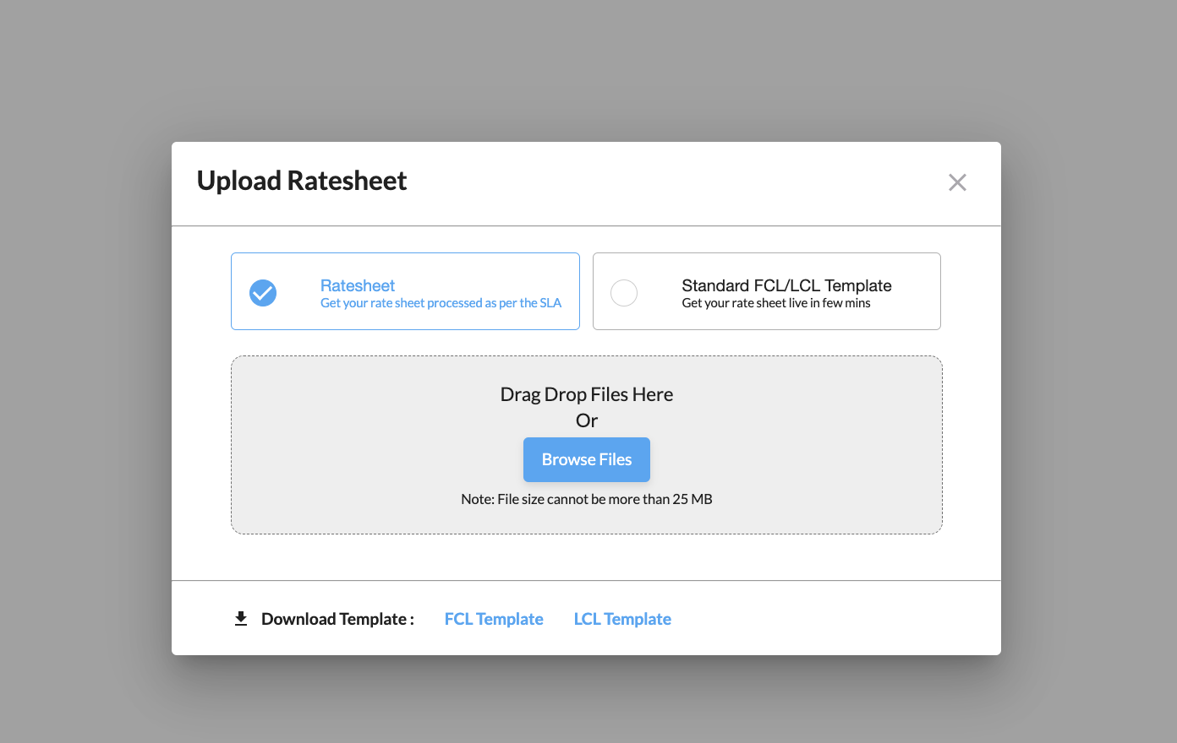

- The user can browse files or Drag & Drop files
- Download the sample template sheet here
→ Preview screen
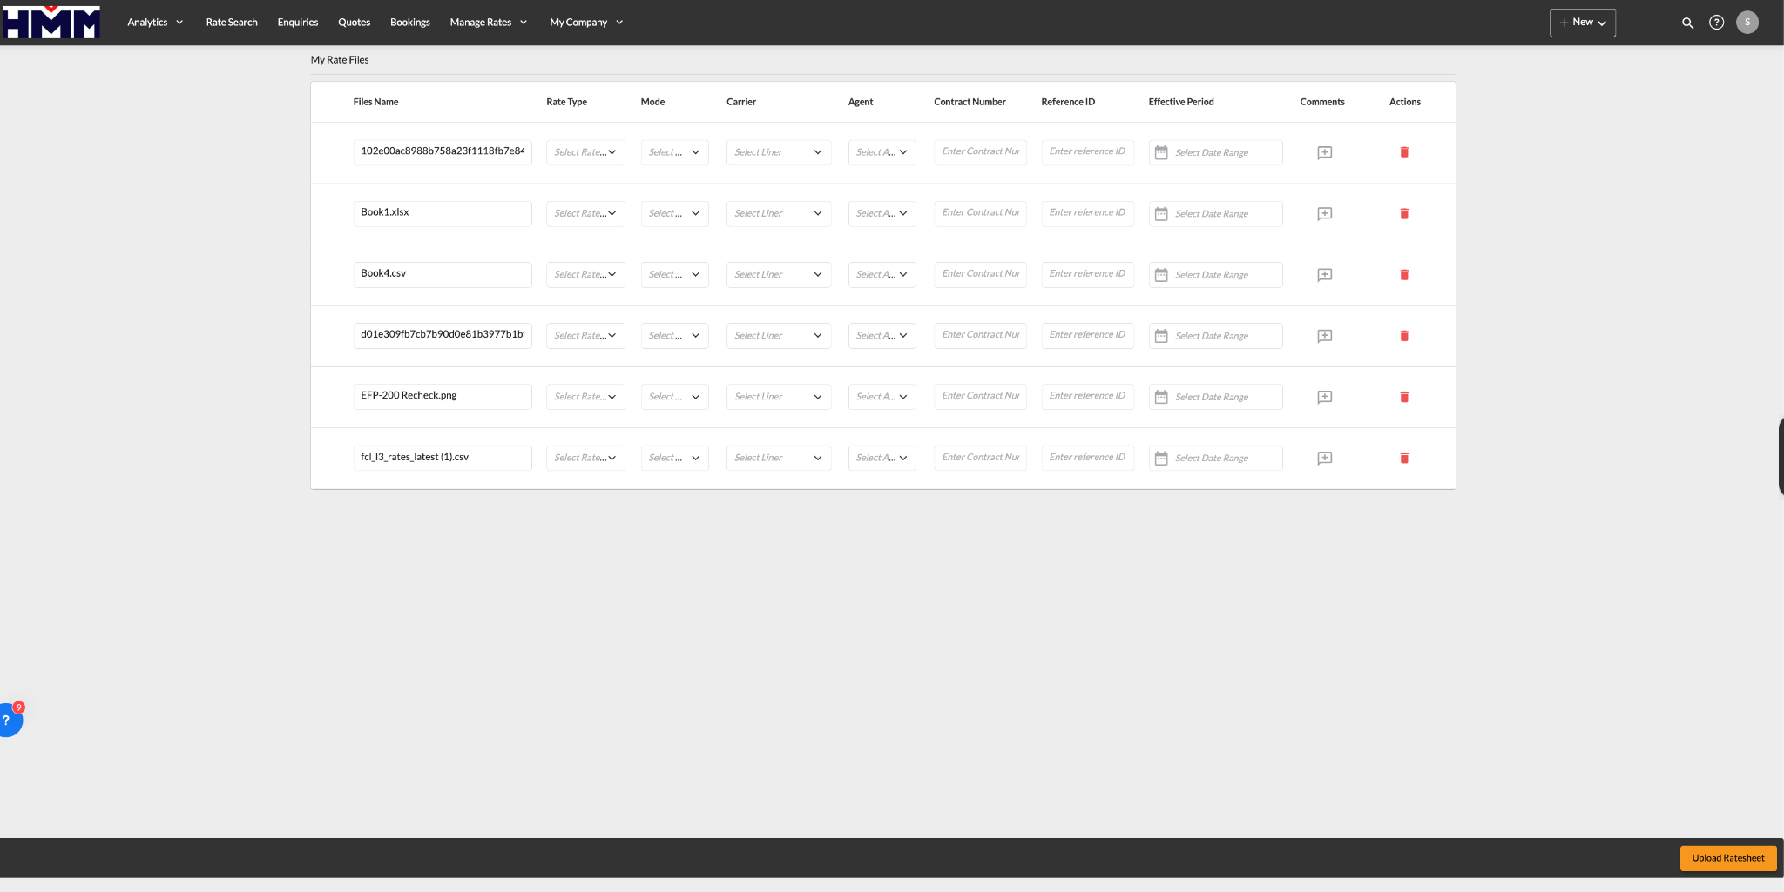
- After filling out the mandatory fields, the user will be able to upload the rate sheets.

→ My rates list screen
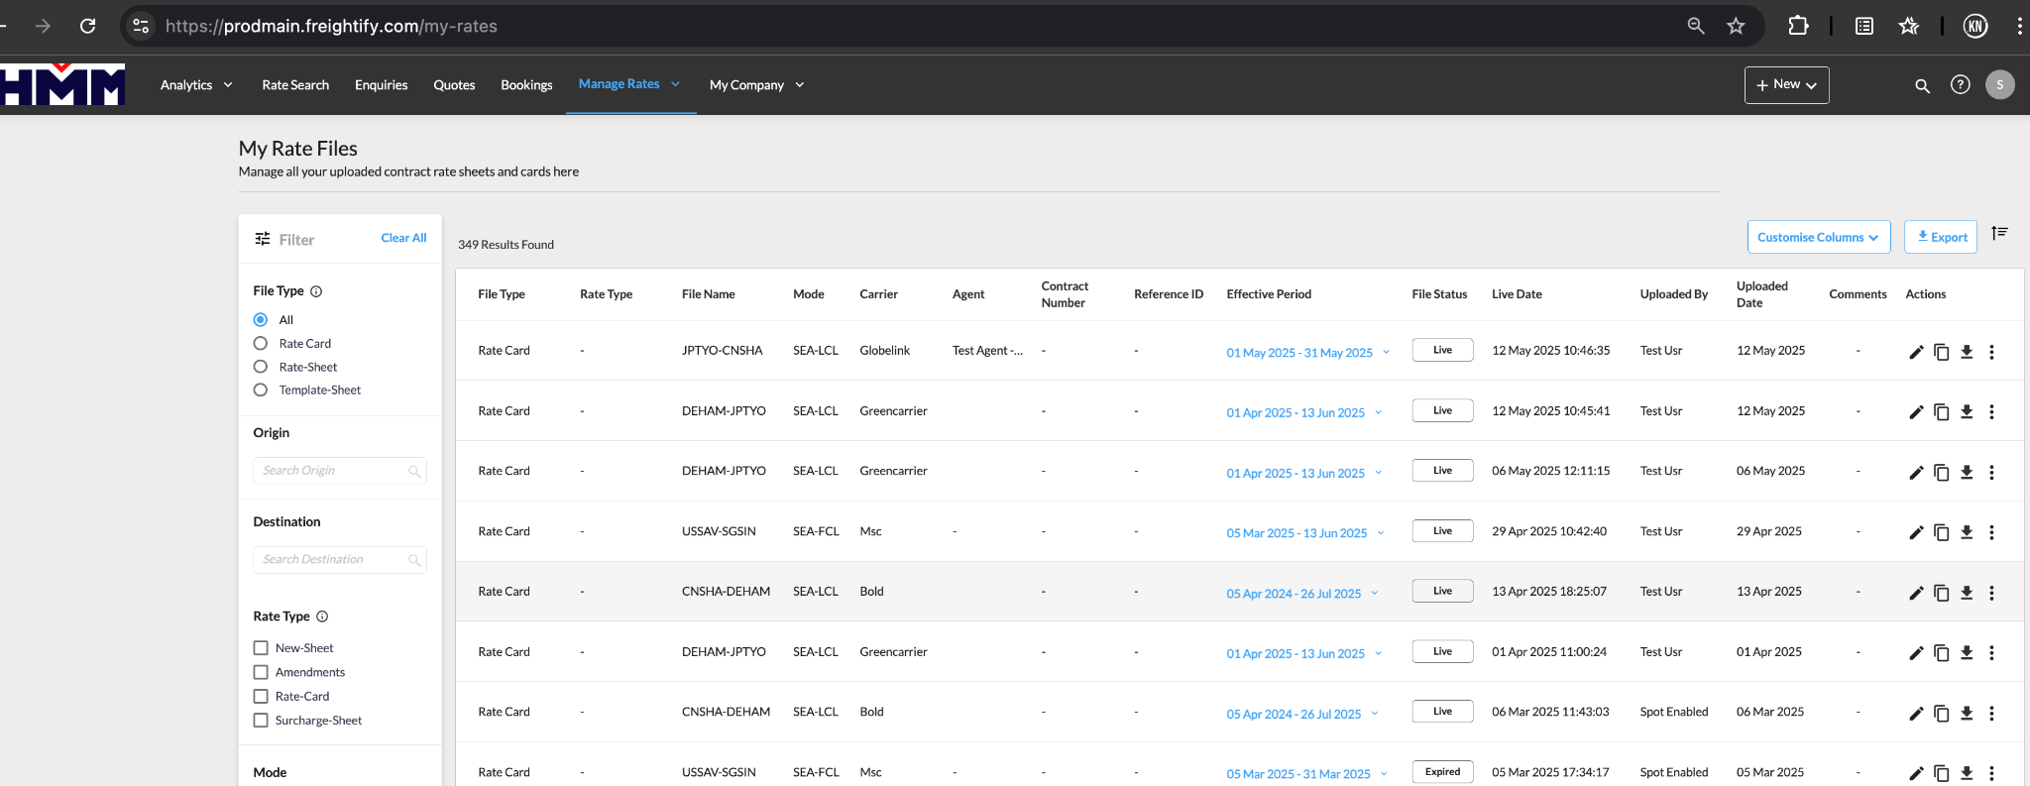

- Once the user clicks the Upload button, we will redirect to the My Rate List screen.

My Rates Rate Upload Database References
- My Rates: rate/myrates_summaries

Admin Files Module
- Displays all uploaded rate sheets.
- Provides filtering and sorting options for file management.
- Offers notifications for new uploads.

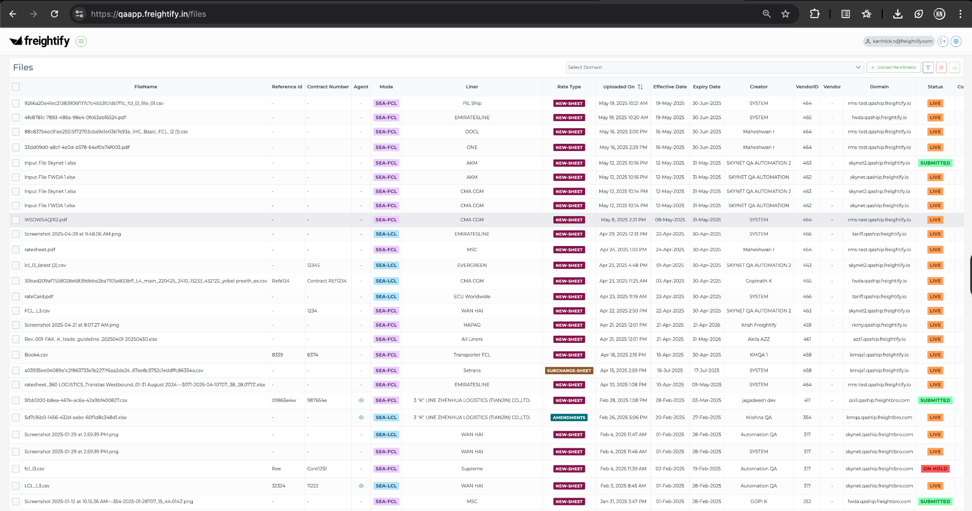

Admin File Database References
- Files: rate/files

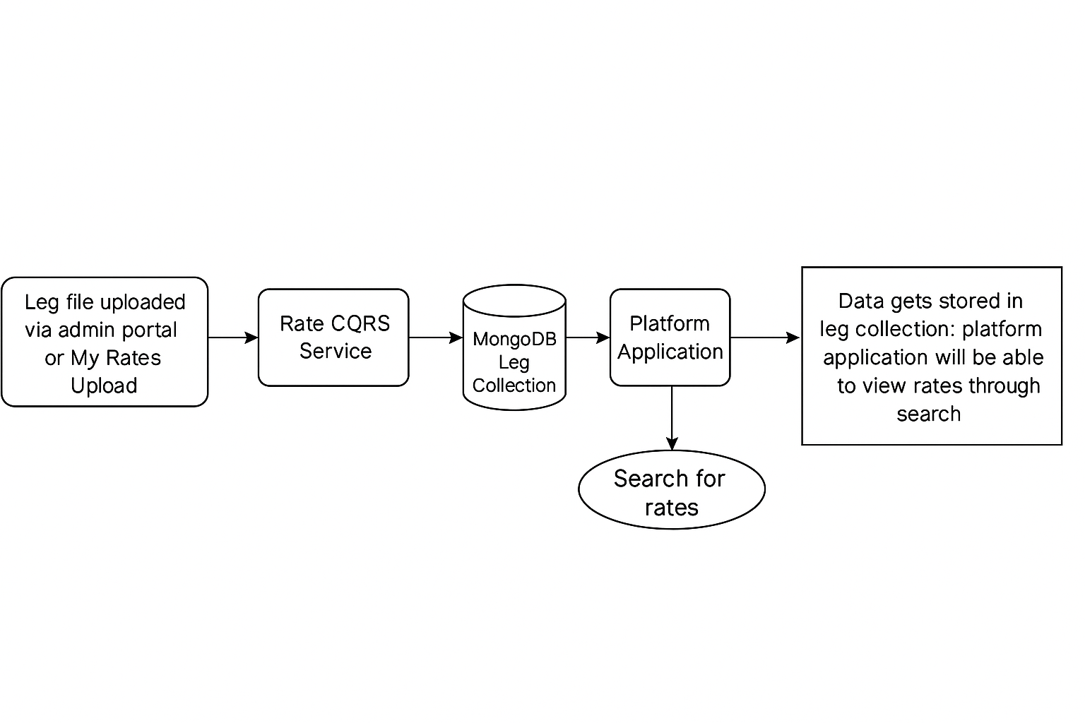

Rate Upload Module
- Supports uploading files by mode (e.g., FCL, LCL, AIR).
- Handles multiple carriers for the same leg.
- Converts uploaded files into system-readable formats and stores them in MongoDB collections.

List Page
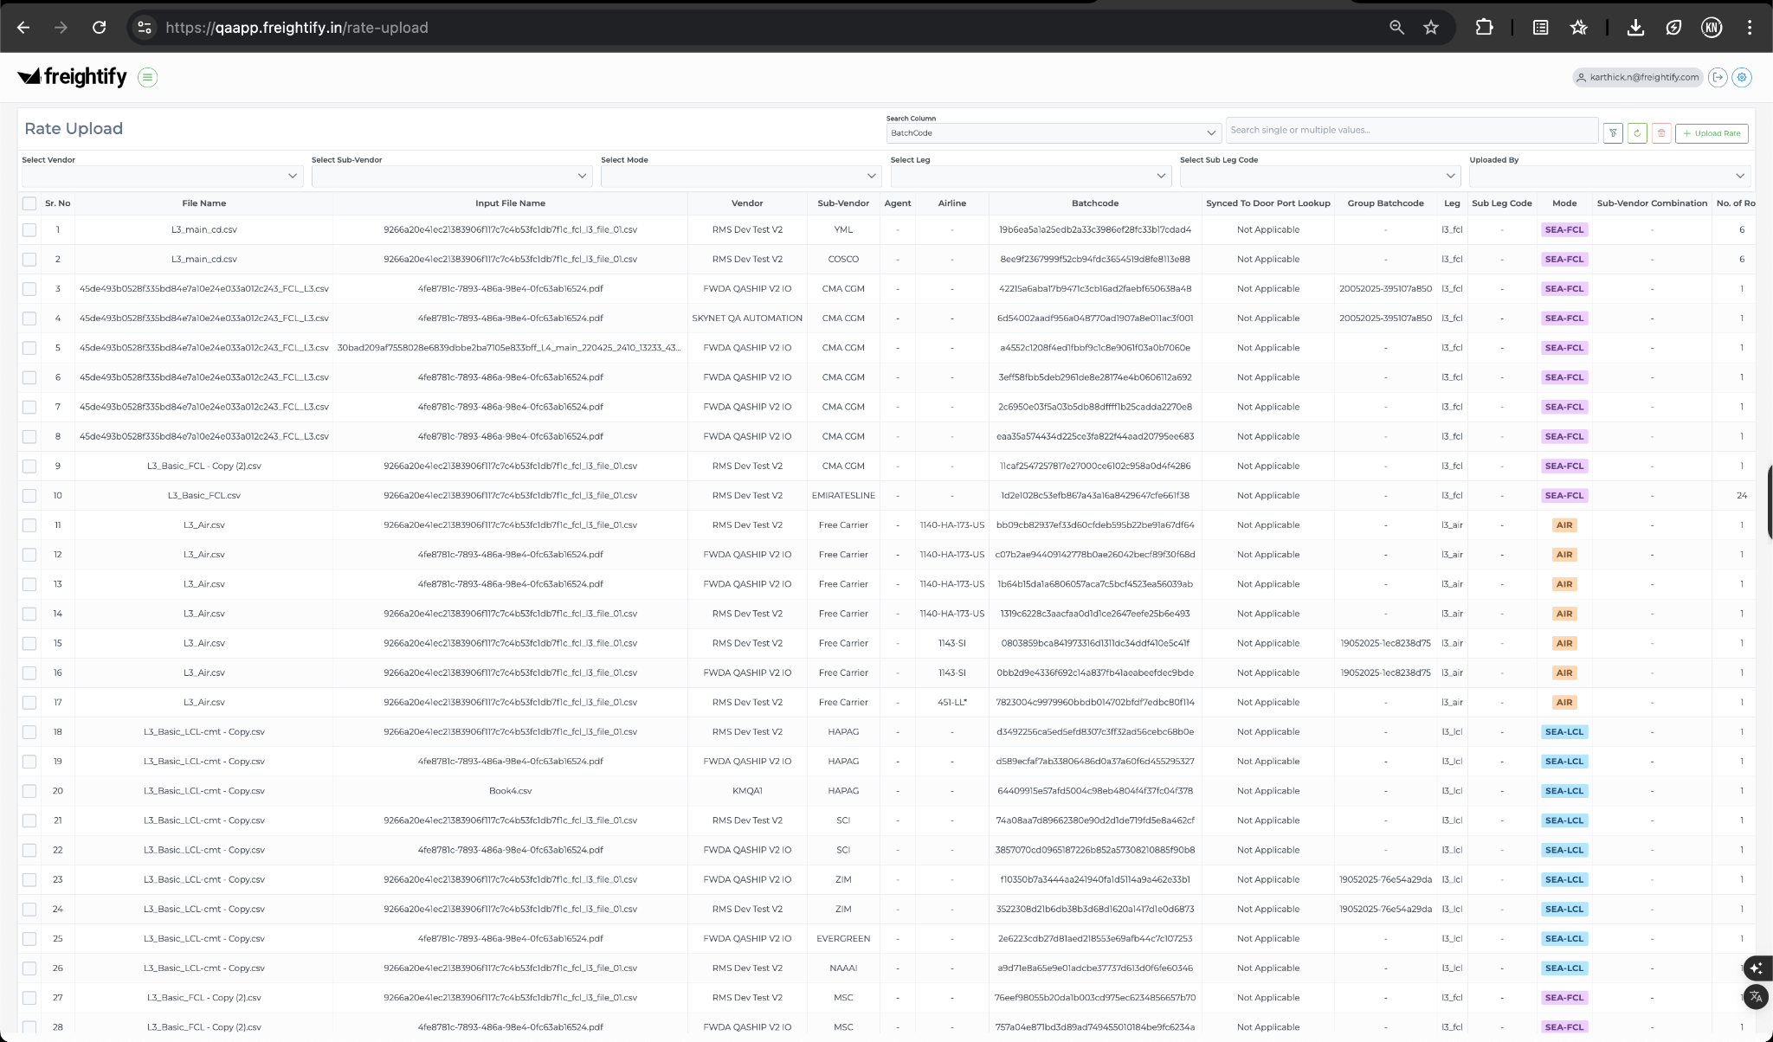

Admin File List Page Database References (MySQL)
- Files: fb_shipper/upload_data_details

Leg File Upload Page
Rates can be created by uploading leg files in admin portal – rate upload page for each mode & leg wise
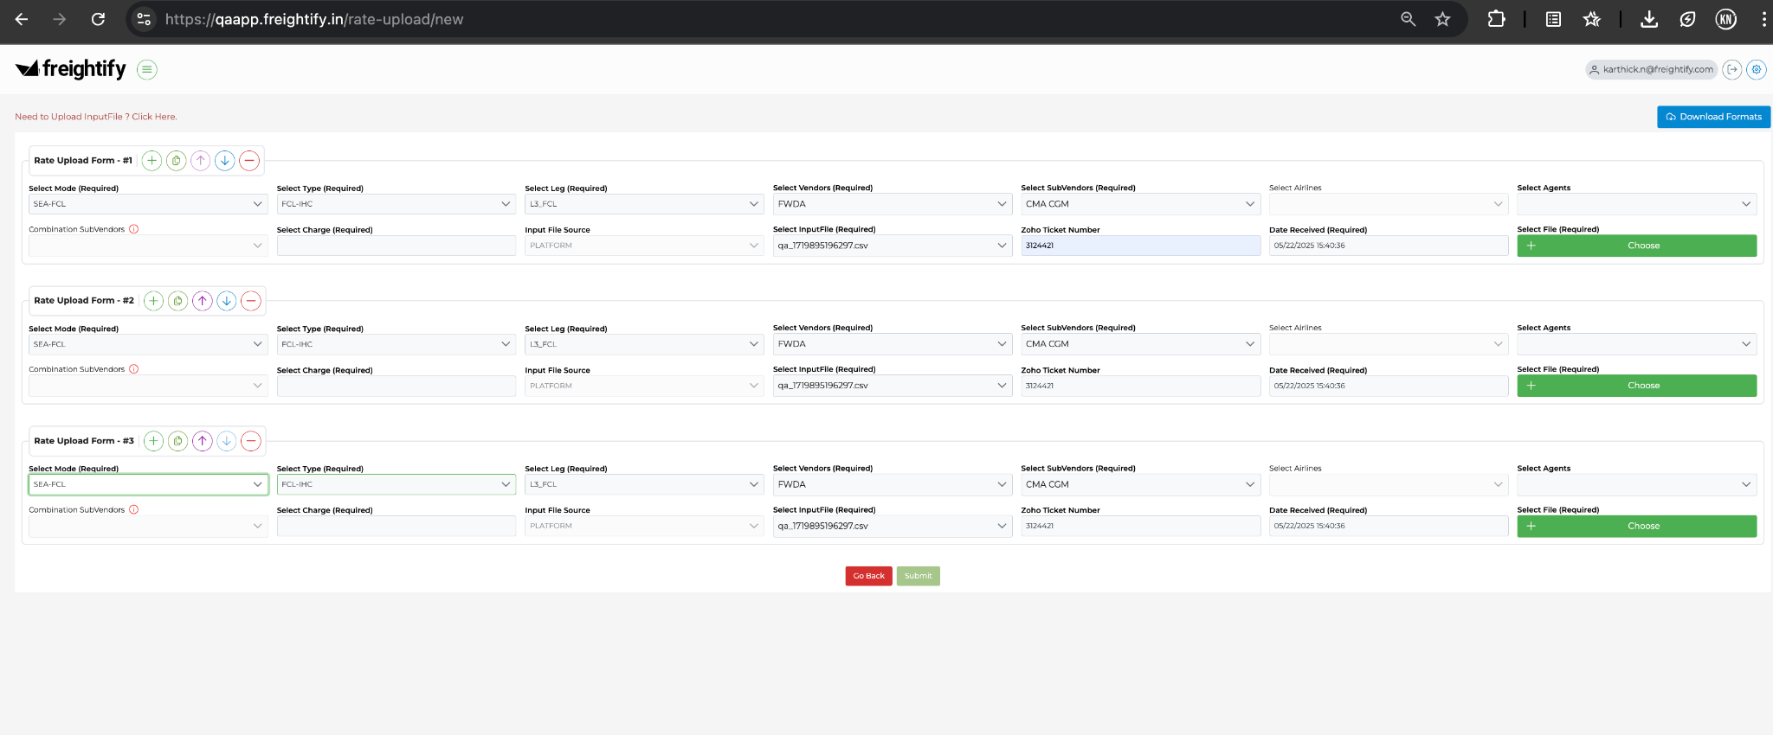

Supported legs for mode-wise
- FCL Mode
  - Standard Legs: L1, L2, L3, L4, L5
  - Sub Legs: L2-Cha, L4-Cha, L3-DND,
  - Slab Legs: L3-Ows, TAO, TAD, L2-IHC, L4-IHC

LCL Mode
  - Standard Legs: L1, L2, L3, L4, L5
  - Sub Legs: L2-Cha, L4-Ch

AIR Mode
  - Standard Legs: L1, L2, L3, L4, L5
  - Sub Legs: L2-Cha, L4-Cha

Leg File Database References

FCL Mode DB Collections
- L1–L5: rate/fcllegs_l{1–5}
- L2-Cha: rate/fcllegs_l2_cha
- L4-Cha: rate/fcllegs_l4_cha
- L3-DnD: rate/demurragedetentions
- Slab Charges: rates/slabcharges
  - L2-IHC: { leg_code: "l2" }
  - L4-IHC: { leg_code: "l4" }
  - L3-Ows: { leg_code: "l3" }
  - L3-TAO: { sub_leg_code: "tao" }
  - L3-TAD: { sub_leg_code: "tad" }
LCL Mode DB Collections
- rate/lcllegs_l{1–5}
- rate/lcllegs_l2_cha
- rate/lcllegs_l4_cha

AIR Mode DB Collections
- rate/airlegs_l{1–5}
- rate/airlegs_l2_cha
- rate/airlegs_l4_cha

Domain Data Keys

There is no domain data keys for controlling the uploading of the leg files; we can upload any leg for any mode from the admin portal

Comprehensive Test Checklist by Category

UI Tests
Scenario | Expected Outcome
Upload UI opens with drag-and-drop & browse options | File dialog and dropzone visible
Preview page loads after file selection | Mandatory fields appear correctly
Upload completes and redirects to My Rates | Navigation and confirmation message shown
Admin file list loads uploaded entries | Files listed with filters, timestamps, and status

Functional Tests
Scenario | Expected Outcome
Upload rate sheet for FCL/LCL/AIR | Upload success, file metadata saved
Upload with missing mandatory fields | Validation error shown
Uploads leg files (L1–L5, sub/slab) | Data stored in appropriate collections
Upload duplicate files | Duplicate handling logic triggered (error or override)
Rate Search | Validate the rates are visible in the platform as per your uploaded records

DB Integrity Tests
Scenario | Expected Outcome
Upload metadata saved in rate/files | Correct file name, uploader, and timestamp
Summary created in rate/myrates_summaries | Forwarder upload record present
Leg data saved in MongoDB | Data structure and fields validated per leg type

Notification Tests
Scenario | Expected Outcome
Upload triggers BP notification | Admin user notified (email/toast/in-app)
Admin views file on file list | Latest upload appears in Admin portal

